theCN online database instructions

Go to Https://theCN.com to login
- Your log-in email IS NOT your email address
- The email you use to login, you will find on the SEFI website
- Begin with your science fair login followed by @sefi.org
- Example: science fair login is AHSMITH
  - theCN login will be AHSMITH@sefi.org
  - Your password is the same password you use for the SEFI website.
- When you login to the SEFI website you should SEE your login credentials for theCN
  - Teachers should be able to access this information on their login for all their students
If you have trouble logging-in or finding the credentials, please e-mail sciencefair@nd.edu

Once you are logged in
- Accept the terms of service (if it appears)
- Click on the gear icon on the upper right corner and
select “Edit Profile/CN Portfolio”

Once you are on your page, you will need to edit your name and put in your project name by clicking on the pencil icon after each section.
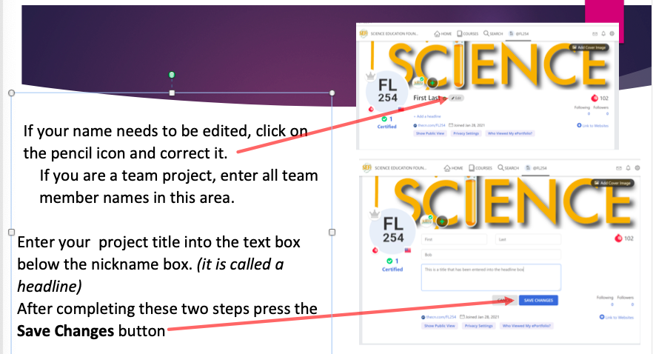
Scroll down to the large box with the “Hoosier Science & Engineering Fair logo. At the bottom of that box is a SolidBlue box that says: “This is an institution created showcase template. Click to view instructions and build your showcase>>”. Click that box and it will take you to the area where you can summarize your project and add images, files, forms, etc. When you are done, do not forget to hit “Submit” on the bottom right-hand side of the page. DO NOT CLICK THE LARGE GREEN CROSS TO ADD A NEW SHOWCASE.

What to UPLOAD:
- Appropriate ISEF forms and NIRSEF participation Form
    - Upload the Completed Quad Chart
      - If you created the Quad chart on paper, you can take a picture of it and upload the image
      - If you created the Quad chart on the computer, upload the file
    - Upload Images from your Presentation
      - If you created a tri-fold, please take pictures of each section and upload them so the judges can see your whole board
    - If you created a Powerpoint, please upload individual slides for the main sections of your presentation
You do not need to upload these all at one time, but all need to be uploaded before February 26.

Your Booth on gather.town will link these documents, so it is important that everything is there and readable.

